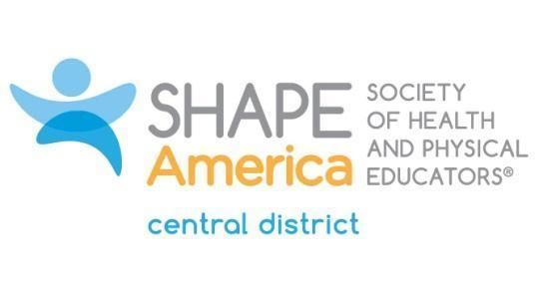

Central District Kathleen Kinderfather Award
This award is to recognize a group or organization (not an individual) who may or may not be members of SHAPE America, but that, through their work in HPERD and/or sport education, has contributed significantly to the district and/or state associations in the district.
To be considered this official nomination form must be completed in detail.
Three letters of recommendation must accompany the application form supporting the group's merits and contributions to HPERD and/or Sport Education.
SPONSOR
First Name:
Last Name:
Mailing Address:
Phone (H):
Phone (W):
Email:
DEMOGRAPHIC DATA OF GROUP OR ORGANIZATION
Group Name:
Mailing Address:
Phone:
Email:
Group Representative:
Mailing Address:
Phone:
Email:
GROUP INFORMATION
Mission:

IMPORTANT CONTRIBUTIONS to SHAPE/HPERD and/or SPORT EDUCATION
- Include up to two additional pages with your application to address this criteria. Examples include: outstanding leadership, community service, innovative teaching practices and/or children and youth program development.
Send this form with other application materials to:
Deb Stephenson: stephensond@sw1.k12.wy.us
Application Deadline: October 15

